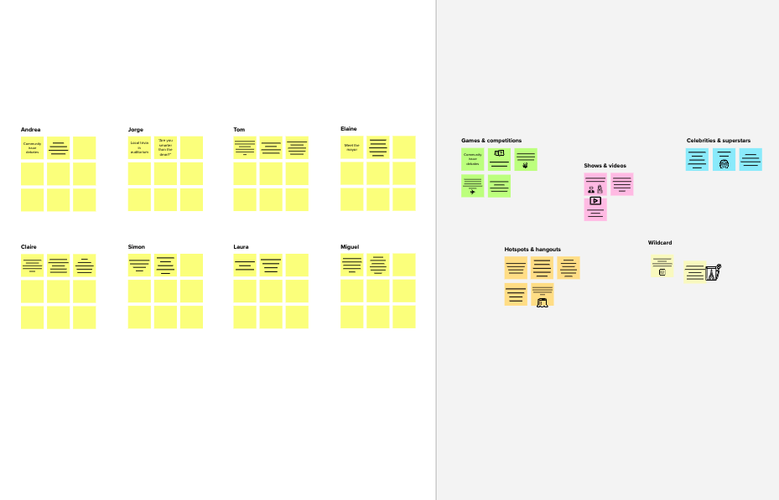

# Fertilizer Recommendation

**TIP**

You can select a sticky note and hit the pencil [switch to sketch] icon to start drawing!



**Before you collaborate**

A little bit of preparation goes a long way with this session. Here’s what you need to do to get going.

**10 minutes**

**Team gathering**

**A**

**1**

**Define your problem statement**

What problem are you trying to solve? Frame your problem as a How Might We statement. This will be the focus of your brainstorm.

**5 minutes**

**2**

**Brainstorm**

Write down any ideas that come to mind that address your problem statement.

**10 minutes**

ASWIN R L

**PRAVIN D**

Build keras image classification model

**3**

**Group ideas**

Take turns sharing your ideas while clustering similar or related notes as you go. In the last 10 minutes, give each cluster a sentence-like label. If a cluster is bigger than six sticky notes, try and see if you and break it up into smaller sub-groups.

**20 minutes**

Category 1

Category 2

**4**

**Prioritize**

Your team should all be on the same page about what's important moving forward. Place your ideas on this grid to determine which ideas are important and which are feasible.

**20 minutes**

**After you collaborate**

You can export the mural as an image or pdf to share with members of your company who might find it helpful.

**Quick add-ons**

Pre-trained model for image classification

Making revolutionary changes in agriculture field

Determining best fertilizer

Identify the disease

Pre-trained model for image classification

Website for Fertilizer recommendation

Cost of using this application is less

Identify the disease

Website for Fertilizer recommendation

# System for Disease Prediction

#### Agriculture is the most important sector in today’s life. Most plants are affected by a wide variety of

bacterial and fungal diseases.

#### Diseases on plants placed a major constraint on the production and a

Define who should participate in the session and send an

invite. Share relevant information or pre-work ahead.

**Set the goal**

**B**

Think about the problem you'll be focusing on solving in the brainstorming session.

**Learn how to use the facilitation tools**



**C**

Use the Facilitation Superpowers to run a happy and productive session.



[**Open article**](https://support.mural.co/en/articles/2113740-facilitation-superpowers)

**PROBLEM**

1. In agricultural aspects, if the plant is affected by leaf disease, then it reduces the growth and productiveness. Generally, the plant diseases are caused by the abnormal physiological Functionalities of plants.
2. People who Grow Crops and facing Issues of Plant Disease .
3. The Traditional methods of Fertilizer prediction and Disease analysis are Expensive and takes a lot of time .

**Key rules of brainstorming**

To ru an smooth and productive session

User friendly website

It reduces man power

Smart solution to solve the problem

**SUBESH S**

Useful to people with no prior knowledge

## 

Deep learning based mathematical model for detecting diseases

Early detection and management of problem

Better utilization of available resources

It simplifies the farmers work

Cost of using this application is less

**KESLIN K**

## 

Fertilizer Recommendation

Instant solution

Interactive user interface to upload images

Pre-trained model for image classification

## 

Portal for farmers

Interactive user interface to upload images

Category 3

Making revolutionary changes in agriculture field

Interactive user interface to upload images

Portal for farmers

Interactive user interface to upload images

It will save time

Admin can view the

recommended fertilizer

through gmail

Interactive user interface to upload images

Improves productivity

Useful to people with no prior knowledge

Build keras

image classification model

Deep learning based mathematical model for detecting diseases

They can find the diseases at early stages

Early detection and management of problem

Deep learning based mathematical model for detecting diseases

Admin can view the recommended fertilizer through gmail

Website for Fertilizer recommendation

Better utilization of available resources

They can find the diseases at early stages

1. **Share the mural**

**Share a view link** to the mural with stakeholders to keep them in the loop about the outcomes of the session.

1. **Export the mural**

Export a copy of the mural as a PNG or PDF to attach to emails, include in slides, or save in your drive.

**Keep moving forward**

**Strategy blueprint**

Define the components of a new idea or strategy.

[**Open the template**](https://app.mural.co/template/e95f612a-f72a-4772-bc48-545aaa04e0c9/984865a6-0a96-4472-a48d-47639307b3ca)

**Customer experience journey map**

Making revolutionary changes in agriculture field

Instant solution

major threat to food security. Hence early and accurate identification of plant diseases is essential to

Stay in topic.

Defer judgment.

Encourage wild ideas.

Listen to others.

**Importance**

If each of these tasks could get

Understand customer needs, motivations, and

obstacles for an experience.

[**Open the template**](https://app.mural.co/template/b7114010-3a67-4d63-a51d-6f2cedc9633f/c1b465ab-57af-4624-8faf-ebb312edc0eb)

#### ensure high quantity and best quality. In recent years, the number of diseases on plants and the degree of harm caused has increased due to the variation in pathogen varieties, changes in cultivation methods, and inadequate plant protection techniques.

Reduces the Cost

Simple UI

Go for volume. If possible, be visual.

Cost of using this application is less

It simplifies the farmers work

Useful to people with no prior knowledge

Cost of using this application is less

Smart solution to solve the problem

They can find the diseases at early stages

## 

Useful to Farmers

Recommends Fertilizers

Utilizing of Resources

done without any difficulty or cost, which would have the most positive impact?

### Early detection and management of problem

Better utilization of available resources

Admin can view the recommended fertilizer through Gmail

Instant solution

**Strengths, weaknesses, opportunities & threats**

Identify strengths, weaknesses, opportunities, and threats (SWOT) to develop a plan.

|  |  |
| --- | --- |
|  |  |
|  |  |

[**Open the template**](https://app.mural.co/template/6a062671-89ee-4b76-9409-2603d8b098be/ca270343-1d54-4952-9d8c-fbc303ffd0f2)

[**Share template feedback**](https://muralco.typeform.com/to/CiqaHVat?typeform-source=app.mural.co)

Improves profiit

**10 minutes** to prepare

[**1 hour** to collaborate](https://muralco.typeform.com/to/CiqaHVat?typeform-source=app.mural.co)

**2-5 people** recommended

**Feasibility**

Regardless of their importance, which tasks are more feasible than others? (Cost, time, effort, complexity, etc.)

**Template**

**Need some inspiration?**

See a finished version of this template to kickstart your work.

[**Open example**](https://app.mural.co/template/e5a93b7b-49f2-48c9-afd7-a635d860eba6/93f1b98d-b2d2-4695-8e85-7e9c0d2fd9b9)